Evan Dreher

Dr. Loretto

Foundations of Academic Discourse

19 February 2021

Euclid’s Oversight

Around 300 B.C. the Greek mathematician Euclid wrote *The Elements*, the pinnacle of mathematics for over 2000 years. Almost all branches of modern math are rooted in it, and while being relevant for over 2000 years is impressive for a textbook, the most impressive thing about it was that it starts with just a few definitions, postulates, and common notions. With nothing but these, Euclid built all of Euclidean geometry. It was a nearly perfect, flawless, and rigid mathematical system apart from one weakness, the fifth postulate.

The first four postulates are so simply put that the fifth postulate almost feels out of place when compared to the others. For example, the 1st postulate says, “Let it have been postulated to draw a straight line from any point to any point” (Euclid, 7). All this postulate says is that any two points can be connected by a line. The fifth postulate is wordier than the first four combined. It says,

If a straight-line falling across two (other), straight-lines makes internal angles on the same side (of itself whose sum is) less than two right-angles, then the two (other) straight-lines, being produced to infinity, meet on that side (of the original straight-line) that the (sum of the internal angles) is less than two right-angles (and do not meet on the other side) (Euclid 7).

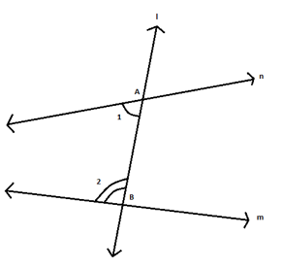

Figure 1

Demonstration of Euclid’s fifth postulate. According to the postulate, if angle 1 + angle 2 < 180 degrees line n and m will meet on the side with angle 1 and angle 2.

Even though it is very wordy, what the fifth postulate really does is define what parallel lines are. British mathematician John Playfair famously reworded it as “given a point not on a given line, there is precisely one line through the point parallel to the line” (Oxford Reference). Playfair’s axiom focuses on the essence of the fifth postulate without all of the technical language. In regular Euclidean geometry the fifth postulate is true, but there are other more perplexing geometries where it is not.

           It was not until over 2000 years after it was originally published that the fifth postulate was proven to not always be true. Russian mathematician Nikolay Lobachevsky “assumed the fifth postulate was not necessary and from this formed a new geometry. In 1840, he explained how this new geometry would work” (Marshall and Scott 2). This new geometry, which would come to be known as hyperbolic geometry, was defined using the following figure.

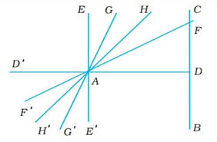

Figure 2

Lobachevsky’s visualization of hyperbolic space. Let EA and CB be perpendicular to AD. In the angle EAD there are several lines some of which will meet BC and some of which will not. These will be separated into cutting and non-cutting lines and AH is the boundary between the two (Marshall and Scott 3).

Simply looking at the diagram shows that the line AG is angled toward BC and therefore they should intersect, but Lobachevsky’s description says they won’t. This is what makes hyperbolic space so different from Euclidean space. In Euclidean space, the distance between two parallel lines remains constant forever. In hyperbolic space however, the distance between parallel lines is constantly in flux with both lines diverging from one another just as AG and BC must in order for them to never intersect. In hyperbolic space, Playfair’s Axiom would be: given a point not on a given line, there are an infinite number of lines through the point parallel to the line.

           Hyperbolic space is a difficult concept to understand, but understanding spherical space makes it easier. Spherical geometry is also non-Euclidean, but rather than all lines diverging, as in hyperbolic geometry, in spherical geometry all lines eventually converge. For example, let’s say a hunter walks a mile south, a mile west, and then a mile north and finds themself in the same spot they were originally. At this spot they find and shoot a bear, what color is it? The correct answer is white because it is a polar bear and the hunter shot it at the north pole. This classic riddle is an example of what happens in spherical space. The hunter walked in a triangle since they only turned twice and ended up at the same spot, but the triangle had 3 right angles which should be impossible.

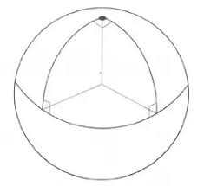

Figure 3. A triangle with 3 right angles in spherical space.

The line going from east to west has two lines laying across it, those being the two lines going north and south. The interior angles sum to exactly 180 degrees since the hunter turned at two right angles. According to Euclid’s fifth postulate the two lines going north and south should never meet, but in the case of the hunter those lines met at the north pole. In spherical space, however, all lines eventually converge on one another, so Playfair’s axiom here would be: given a point not on a given line there are no lines through the point parallel to the line. This makes sense using the Earth as an example of a spherical plane. This is not a perfect representation, but it sufficiently conveys the idea that all lines eventually converge.

Hyperbolic space is much harder to visualize, but one of the best projections of it is called the Poincare disc as pictured below.

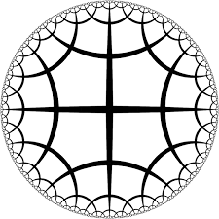

Figure 4. Poincare Disc. Every black curve on the Poincare Disc is a straight line on the hyperbolic plane

The Poincare disc above is composed of pentagons with five right angles for a total of 450 degrees. A Euclidean pentagon has internal angles summing to 540 degrees, but in hyperbolic space the sum of the internal angles of a polygon is always less than that of the same polygon in Euclidean space.

Looking back at the Lobachevsky model in figure 2, the line AG was categorized as a non-cutting line, meaning it never intersects with line BC. The Poincare disc shows that line BC bends away from line AG so that the two never meet even though the internal angles GAD and ADC sum to less than 180 degrees. This is the type of phenomenon that happens in hyperbolic space because of Lobachevsky’s assumption that the fifth postulate is not always true.

Euclid was obviously a genius mathematician, but his masterpiece had one flaw and it puzzled some of the greatest mathematicians for two millennium. But people are nothing if not stubborn, and so they spent those 2 millennium desperately trying to prove or disprove his fifth postulate wrong. And when someone finally did, it opened a path to whole new worlds of perplexing geometries to boggle the minds of geometers and fanatics for years to come.

Works Cited

Euclid. *The Elements.* Translated by Richard Fitzpatrick, 2008 <http://farside.ph.utexas.edu/Books/Euclid/Elements.pdf>. Accessed 19 February 2021.

Marshall, Daniel, Paul Scott. *A Brief History of non-Euclidean Geometry*. <https://files.eric.ed.gov/fulltext/EJ717835.pdf>. Accessed 19 February 2021.

Oxford Reference. *Oxford University Press.* <https://www.oxfordreference.com/view/10.1093/oi/authority.20110803100331376>. Accessed 19 February 2021.